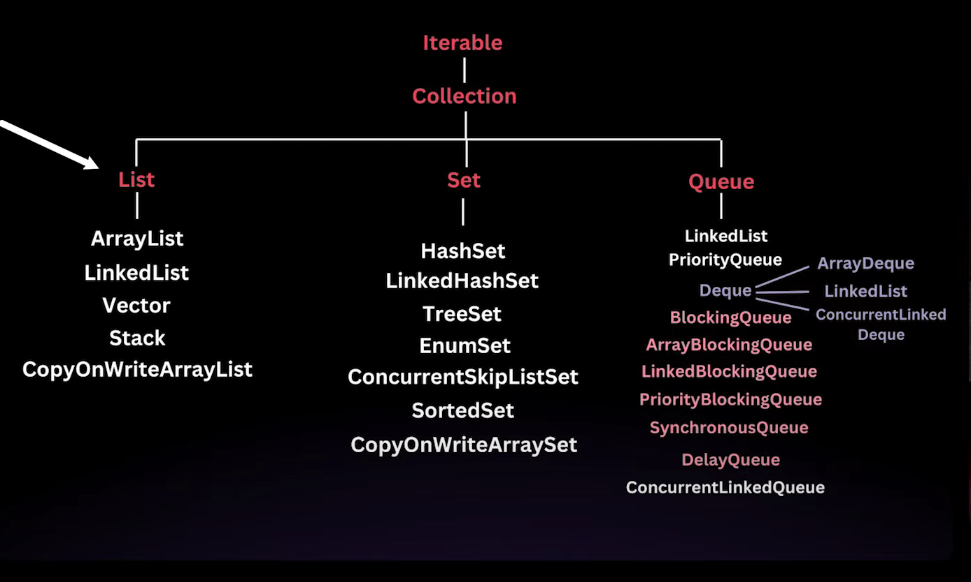

* Iterable is a Interface
  + Method like **For-each** can be used
* Collection is a interface and it extends iterable (means it has iterable methods)
  + **Add()**
  + **Remove()**
  + **Size()**
  + **Clear()**
  + **Contains()**
  + **Etc.**
* List is interface and is sub interface of the collection interface
  + List has to be used for **ordered elements / sequence and contains duplicate**
  + Index based access
  + We need to use list when we don’t know the size

1. **List**
2. **ArrayList**

* ArrayList to be used when we don’t know the size
* ArrayList<Type> array = new ArrayList<>();
* We can use all the collection method using the object, here = “array”
* We can iterate over this coz it extends iterable